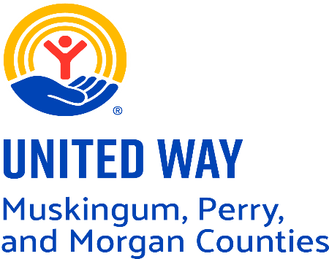

We’re looking for a dynamic, detail‑driven fundraising professional who thrives in a small, mission‑focused team and is ready to lead our development efforts with confidence and creativity. This role is perfect for someone who is energized by building donor relationships, skilled at managing CRM systems, talented at managing multiple media sources and motivated by the opportunity to grow community support and philanthropic investment. If you’re proactive, personable, and inspired by meaningful impact, we’d love to connect.

What We’re Looking For
- Proven experience in fundraising, development, and community engagement
- Confident and skilled in making donor outreach calls and securing financial support
- Confidence and skill in delivering presentations to donors, partners, and community groups
- Experience managing donor databases and CRM platforms
- Ability to create compelling fundraising materials, campaigns, and donor‑focused content
- Strong organizational skills, time management, and attention to detail
- Exceptional written and verbal communication
- Reliability, accountability, and a willingness to take ownership of projects
- Creative problem‑solver with a positive, solution-oriented mindset
- Professional presence with high energy and enthusiasm for donor engagement
- Ability to collaborate effectively within a small, close‑knit team
- Genuine motivation to strengthen community engagement through philanthropy

