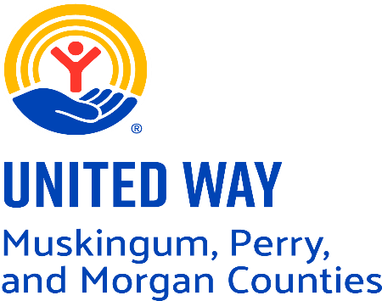

Seeking Community Engagement Coordinator
United Way of Muskingum, Perry, and Morgan Counties – This Tri-County United Way is a 501(c)(3) nonprofit organization whose mission is to provide strong leadership in uniting volunteers, agencies, and resources to help meet the needs of our communities through cultivation of Healthy Communities, Youth Opportunity, Financial Security, and Community Resiliency. To learn more visit www.unitedwayofmpm.org
Responsibilities – The Community Engagement Coordinator, reporting to the Chief Executive Officer (CEO) will focus on:
-Leading annual campaign activities which includes campaign presentations, donor outreach calls, and securing financial support
-Process donor pledges and gifts
-maintain and updated donor management database
-Initiate relationships with prospective donors
-Generate and report out on data to support fundraising planning and strategy
-Manage campaign materials, inventory and logistical details
-Give public campaign presentations
-Coordinate campaign tools such as toolkits and timelines
-Donor cultivation and retention
-Serve as the point of contact for all donor related activities
-Create, schedule and publish social media content
-Photo and video collection for media
-Content creation
-Coordinate and Represent the organization in the media such as radio, television, and press releases
Skills/Expectations:
-Strong organizational skills
-Time management skills
-Strong attention to detail
-Exceptional written and verbal communication skills
-Reliable and accountable
-Willingness to take ownership of projects
-Creative
-Problem Solver with solution-oriented mindset
-Professional presence
-High energy
-Ability to collaborate effectively within a small team
-Highly motivated
Benefits:
-Annual starting salary range: $41,500 – $44,000
-Insurance coverages include Health, Dental, Vision, Life & Disability
-Matching up to 3% SIMPLE IRA
-Accrued paid time off, 5 personal holidays, sick time after the first year, and 13 paid holiday
-Business-related travel expense reimbursement
-Company owned laptop provided for business use
-Hybrid work schedule
-Flexible work environment to support work /life balance

Available Now - apply today to nconrad@unitedwayofmpm.org. Email your personal letter and resume explaining why this role is made for you and how your experiences align with the stated responsibilities and expectations.

